Restorative / Pro-amnesty
Robert McBride
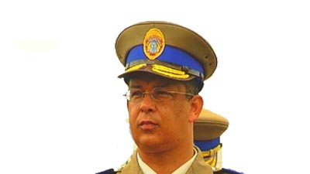
During apartheid, he was a member of the Umkhonto we Sizwe the armed wing of the ANC (African National Congress). He grew up in Wentworth, a racially segregated suburb. He developed political views at an early age due to influences from his father. He is best known for his leadership of the bombing of the “Why Not” Restaurant and Magoo’s Bar in Durban June 14, 1986. Three white women were killed and 69 people were injured. He was sentenced to death and released in 1992 after his actions were classified as politically motivated but, he was granted amnesty at the TRC (Truth and Reconciliation Commission). After apartheid, McBride was a candidate for the position of chief of Ekurhuleni’s metro police. The Citizen newspaper opposed his appointment and regarded McBride as “Blatantly unsuited” and referenced the bombings for which he had been granted amnesty. McBride sued the paper for defamation arguing that when someone is granted amnesty, a person’s “conviction shall for all purposes… be deemed to not to have taken place.” The High Court and Supreme Court of Appeal in Johannesburg held that the effect of being granted amnesty was no longer permitted to be branded with titles such as criminal or murderer.

ARTICLES:
Robert McBride (police officer). (n.d.). Retrieved from http://en.wikipedia.org/wiki/Robert_McBride

"Case Law: Citizen 1978 Ltd v McBride - South African Constitutional Court Takes off the Muzzle - Dario
Milo." Inforrms Blog. N.p., 18 Apr. 2011.

Keller, Bill. "Conversations/Robert McBride; A Bomber Lives with His Guilt in a Land of Scant Innocence." New York Times, Late Edition (East Coast) ed.Oct 18 1992. ProQuest. Web. 15 Dec. 2015 .

LaFRANIERE, SHARON. "A South African Journey: Bomb Maker to Police Chief." New York Times, Late Edition (East Coast) ed.Feb 28 2004. ProQuest. Web. 15 Dec. 2015 .

Duke, Lynne. "S. African Official's Arrest Stirs Talk of Plots at Home and Abroad." The Washington Post: A16. Mar 18 1998. ProQuest. Web. 15 Dec. 2015 .

BOOKS:
(none available)

VIDEO:
(non available)

