Peter Takirambudde
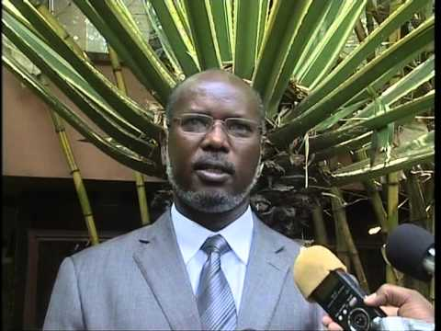
Peter Takirambudde is the Ugandan born Executive Director of Human Rights Watch for Sub-Saharan Africa. Before joining Human Rights Watch in 1995, he was a professor at the University of Botswana. He is a lawyer by training, and a graduate of Makerere University in Uganda. Takirambudde earned a degree in international business from Yale University, and has reported on human rights abuses in places such as Liberia and Cabinda. He had this to say about SA’s repeated offers of amnesty: “Granting repeated amnesties can lead to a culture of impunity, and that is exactly what South Africa needs to avoid.”
ARTICLES:
Ford Foundation appoints Peter Takirambudde to lead its Southern Africa office. PR Newswire. http://www.prnewswire.com/news-releases/ford-foundation-appoints-peter-takirambudde-to-lead-its-southern-africa-office-129084528.html

Fletcher, Pascal. US Africa Command: AID crusader or meddling giant? Mail & Guardian: Africa’s best read. Oct. 1, 2007. http://mg.co.za/tag/peter-takirambudde

BOOKS:

“Ford Foundation appoints Peter Takirambudde to lead its Southern Africa office.” PR Newswire.
http://www.prnewswire.com/news-releases/ford-foundation-appoints-peter-takirambudde-to-lead-its-southern-africa-office-129084528.html

Mutwol, Julius. Peace Agreements and Civil Wars in Africa. Amherst: Cambria Press, 2009. Web. 25 Jan. 2016 https://books.google.com/books?id=vcVq5_LRLsUC&pg=PA306&dq=Peter+Takirambudde+amnesty&hl=en&sa=X&ved=0ahUKEwi4-eHv_MXKAhVPw2MKHQt7BokQ6AEIOzAE#v=onepage&q=Peter%20Takirambudde%20amnesty&f=false
P. 306

VIDEO:

